**Lab 7 Assignment_Spanning Tree Protocol and Virtual LANs_AnswerSheet**

Student Name:­ Mark Van Wormer

***Important*: Follow the instruction from the document, practice using packet tracer. Submit the ANSWER SHEET to Bb.**

**Activity 1: Creation of a switched LAN**

5. Check the IP configuration settings, record the MAC addresses for each of the host in Table 1. (3 points)

|  |  |
| --- | --- |
| PC Name | MAC Address |
| Faculty 1 | FE80::260:5CFF:FE7A:8357 |
| Faculty 2 | FE80::2E0:F7FF:FED0:10DD |
| Faculty 3 | FE80::2E0:A3FF:FE36:384D |
| Staff 1 | FE80::206:2AFF:FE97:BB25 |
| Staff 2 | FE80::2E0:8FFF:FE69:2306 |
| Student 1 | FE80::201:96FF:FEDA:EA96 |
| Student 2 | FE80::20A:F3FF:FE83:B94B |
| Student 3 | FE80::210:11FF:FE7A:C1D3 |

Table 1. PCs and MAC address assignment

7. If you want to **broadcast** an IP packet within the current switched LAN from Faculty 1’s PC, what destination IP address you need to use? Write down the ping command here. (2 points)

Ping 192.168.1.255

8. Capture the screenshot of replies based on the 7. (2 points)

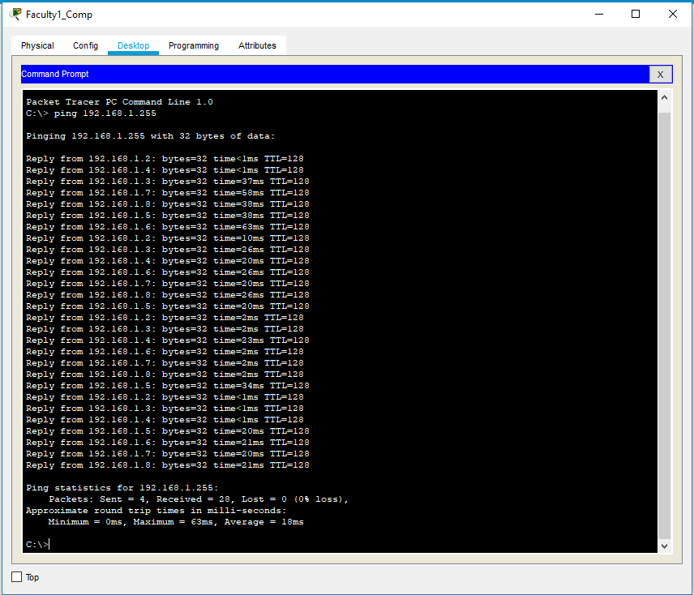

9.2 After the additional links are added, wait for a moment until the network reaches its convergence state in which there is only single delivery path between any two hosts. After the convergence, how many of the switch ports turned red, indicating they are blocked by the STP protocol? List the blocked switches and the port in the Table 3 (You can add rows to the table if it is needed). (3 points)

|  |  |
| --- | --- |
| Switch Name | Port (interface) |
| Switch 2 | Fa0/3 |
| Core Switch | Fa0/3 |
| Switch 2 | Fa0/4 |
| Switch 2 | Fa0/2 |
|  |  |
|  |  |

Table 3. Blocked Switch Ports

**Activity 2: Setup 3 VLANs on 1 subnet**

* 1. Based on the current VLAN setting, issue below ping commands on the Faculty1 PC’s command prompt. Record the result and logically explain the outcomes in the Table 6.

(4 points)

|  |  |  |
| --- | --- | --- |
| Commands | Receive messages (Y/N) | Why? |
| Ping 192.168.1.3 | Yes | Same VLAN |
| Ping 192.168.1.4 | No | Different VLAN |
| Ping 192.168.1.8 | No | Different VLAN |
| Ping 192.168.1.255 | Yes | Pings to other 2 faculty computers |

Table 6. Question 3.1

* 1. Based on the current VLAN setting, issue below ping commands on the Staff 1 PC’s command prompt. Record the result and logically explain the outcomes in the Table 7.

(3 points)

|  |  |  |
| --- | --- | --- |
| Commands | Receive messages (Y/N) | Why? |
| ping 192.168.1.1 | No | Different VLAN |
| ping 192.168.1.5 | Yes | Same VLAN |
| ping 192.168.1.6 | No | Different VLAN |

Table 7. Question 3.2

1. Capture a screenshot of the result of the ping command of **ping 192.168.1.5** from Staff 1 PC. (3 points)

